EPT REPORT 17-12-2022 ANISH V R – VENKATA SAI

We started figuring out all Electrical devices that work on 12v and 5 v

Assembled back the AC-DC converter and Wired back the DC-DC converter

CHECKLIST:

|  |  |
| --- | --- |
| Electrical Parts | Working Condition |
| Head Lights | Both Are Working |
| Horn | Working |
| Indictor Lights | Working |

The AC-DC converter works in the conversion of 220v to 34-24.5 V and DC-DC converter converts 24V to 12V+ and 12V-

We were checking all voltmeters and the clamp Voltmeter, we need some AA batteries for that to run

Checking out the connections between throttle and the Kelly controller

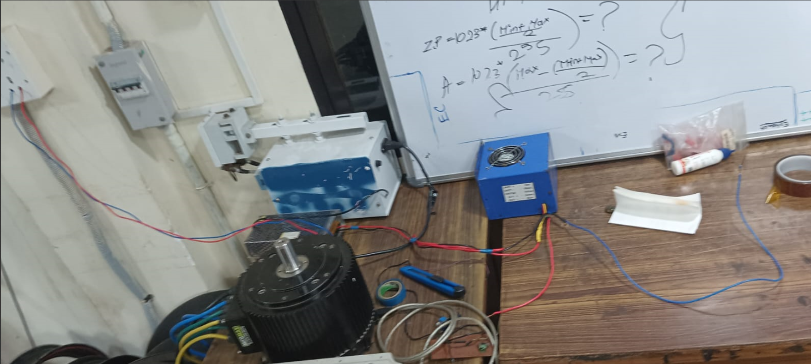

ANISH – HOME WORK (DONE)

Sorted out the circuit diagram for ELECTRONICS POWER BAY:

